**Change AP Check Number**

1. Go to Network System Administrator
2. Go to Run Custom Utility Program

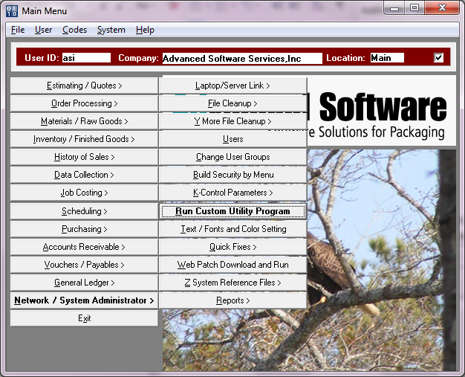

1. Find and double click on chgapchk.r

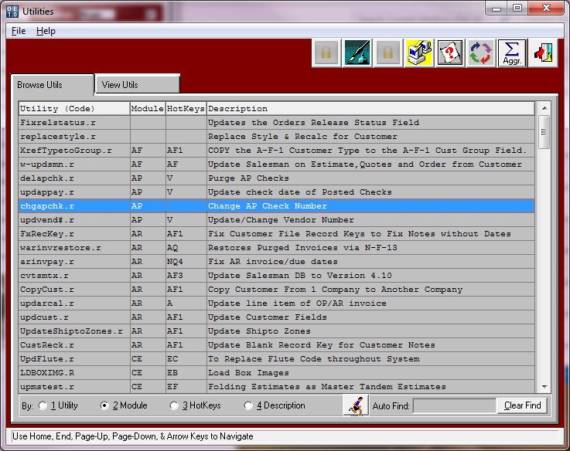

1. Click the man running button

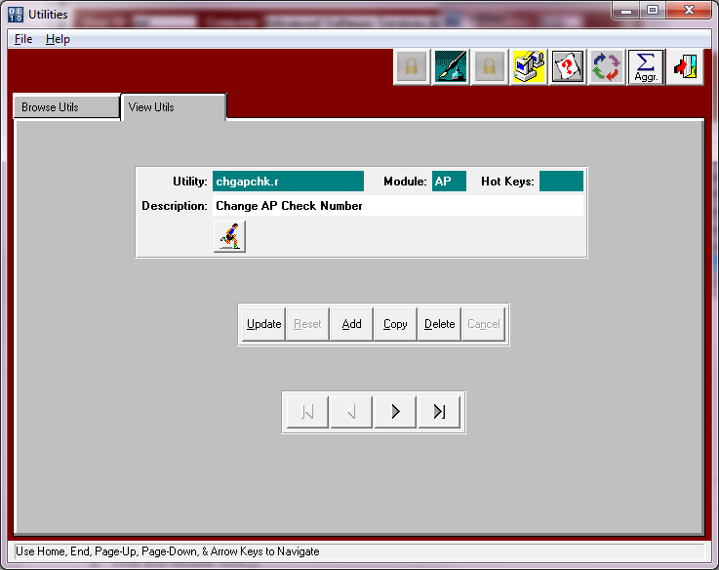

1. Fill in the bank code (If you do not know it, go to GF4 (Banks on the General Ledger File Maintenance Menu))
2. Fill in the Old Check Number (the one you want to change or posted wrong)
3. Fill in the New check number (the one you printed or want to change to)
4. Click the Start Process button. You must do this for each check you want to change separately.

